**Abstract:**

IBM z/OS Change Tracker is a System Software Change Control and Management solution for the z/OS platform via a z/OSMF plugin.. It allows for tracking, control, and management of systems software configuration changes, and can identify and report on system-wide changes.

This lab will walk you through the different functions that can be utilized with the z/OSMF Plug-in. This self-directed lab will show you how to protect a resource, check in/out a member and how to compare members to the backups.

*Change Tracker is available on z/OS V2.5 and above. IBM offers a 90-day trial period for Change Tracker.*

Exercise instructions

The Exercise instructions heading should use paragraph style ***Heading 2 (new page)***.

You can start a new part of the exercise with an introductory paragraph, or jump directly to the steps required to complete the part.

When composing exercise steps make sure you start with a major numbered step using style ***Steps***. This numbered step describes what will be done. Experienced students can attempt to complete this step just by reading and doing what’s in the numbered step. Follow with lettered steps which describe in detail how to accomplish the major step. These minor steps are also of style ***Steps***, but are indented using the tab key, or the indent buttons on the toolbar.

See the example below:

After following this self-directed lab, you will have gained a high-level understanding of the following topics:

1. Logon to z/OSMF
2. Monitor a data set
3. Locking a data set
4. Check out a member
5. Audit function
6. Compare changes via backups
7. Recover
8. Check in a member
9. Remove data sets from the protection list

Note: Each user of this lab will go through each step in this exercise but that would not be the case in a production environment. See below which user would handle each different task.

Administrator: Monitor a data set, lock a data set, check in a member, and Removing data sets from the protection list.

Auditor: Audit Function.

General User: Compare changes via backups and Recovery.

#2b

* 1. Logon to z/OSMF.

#1a

In this step, we will login to z/OSMF to use the Change Tracker function. For this lab, we are using a z/OSMF 3.1 system.

1. Go to <https://share.centers.ihost.com/zosmf/> on the Firefox or IE web browser. (If you want to follow this lab on your own system, that is fine. Just note some of the samples we use you will need to supply yourself, using the Appendix to find those samples).
2. Using the userid you were given (SHARAnn, SHARBnn, or SHARCnn) and the password, logon to z/OSMF. The userid you were given is a regular z/OS userid on this system and has been given access to z/OSMF. There is *no* z/OSMF code on this workstation, all executables (except the web browser) is on the z/OS system.
3. Click on “LOG IN”.

**https://share.centers.ihost.com/zosmf/**

1.a

1.b

1.c

Enter the IBM z/OS Change Tracker Plug-in

1. Double-Click “IBM z/OS Change Tracker”.

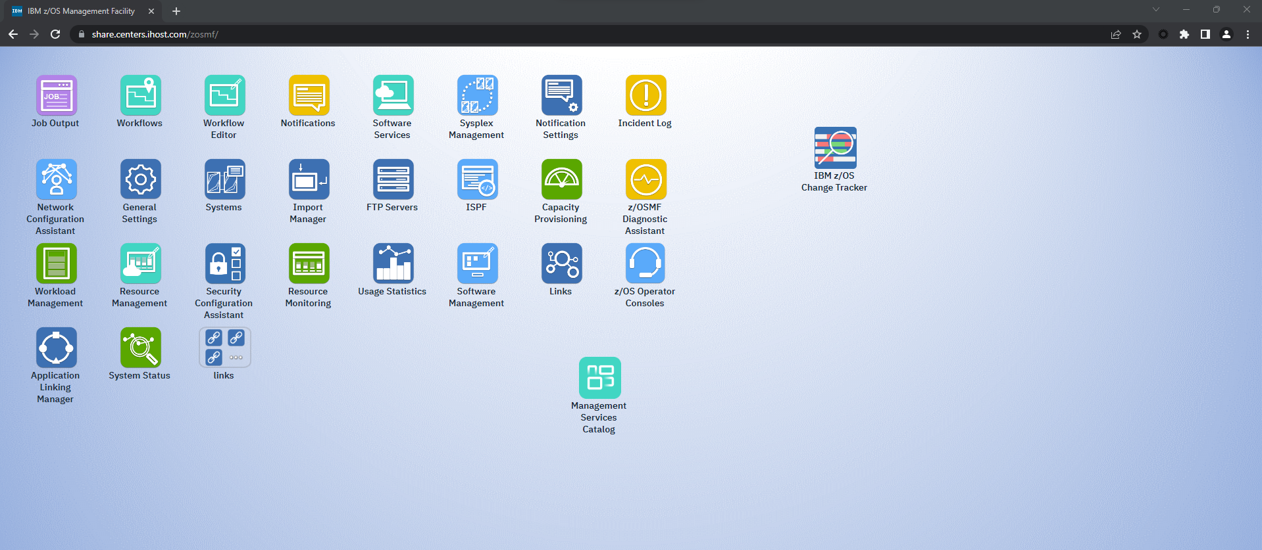

1.d

If the Change Tracker Icon is not on the desktop, follow the steps below to add it.

1. Click the App Center Icon in the lower left corner.

1.i

1. App center will pop up in a new display and scroll until you find Change Tracker.
2. After finding Change Tracker, you can either click and drag the icon to the desktop OR right-click on the icon and select “Send to Desktop”.

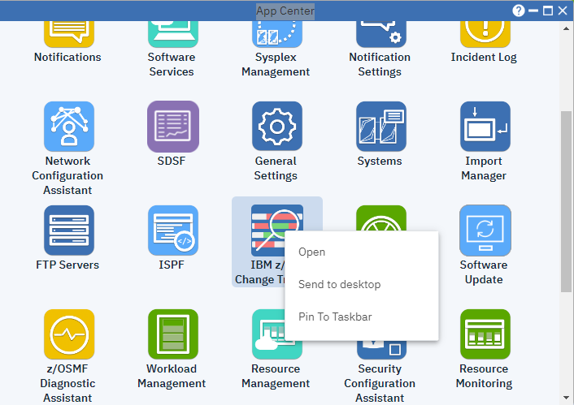

* 1. Monitor a data set

In this step, we will monitor two data sets. The two data sets that you will monitor will be SHARA***.SHARE.DEMO1 & SHAR***.SHARE.DEMO2. You may already see some data sets are being monitored, ignore as those are other users.

1. Click “Protect data set” in the right corner of the Monitored Resources panel.

2.a

1. The following window will pop up.

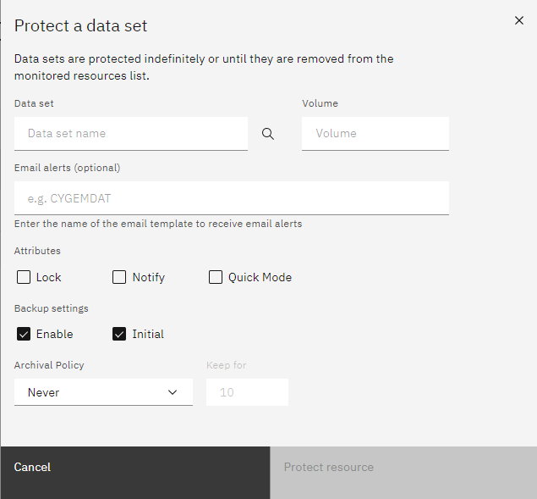

We will need to provide information regarding the data set and the default options we want when the data set is monitored. Update the panel with the following information:

1. Data Set: enter SHAR***.SHARE.DEMO1 as the Data Set name.
   * Replace SHAR*** with the userid that was provided to you.
2. Email Alerts: Not applicable for this exercise.
   * Change Tracker has functionality that will alert you by email if the data set was used.
3. Attributes: For this step we will leave each attribute unchecked. We will discuss “Lock” in the following steps.
   * Notify: would be checked if you wanted email alerts.
   * Quick Mode: Used in conjunction with Initial = NO, meant for data sets with many members.
4. Backup Settings: make sure “Enable” and “Initial” are checked. Change “Archival Policy” to Copies and “Keep for” to 5.
   * By choosing “Enable” we are enabling backups of the data set and its members.
   * “Initial” means an initial backup will be taken for the original members.

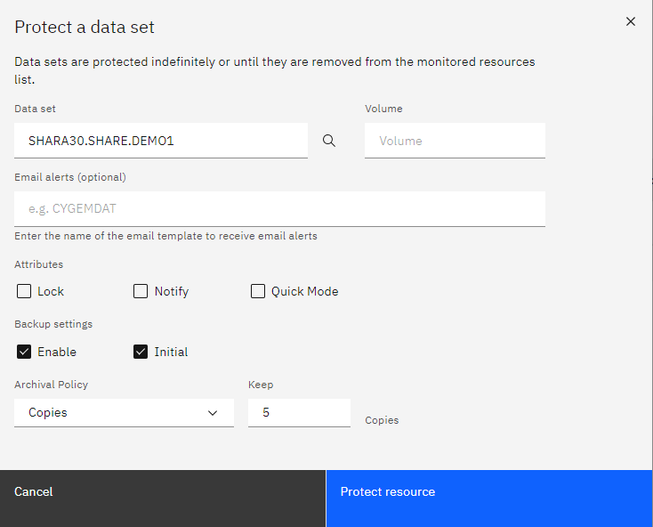

2.g

2.f

2.e

2.d

2.c

1. After adding all the information to the panel, click “Protect resource” in the lower right corner.
2. Repeat Steps 2.a – 2.g with data set SHAR***.SHARE.DEMO2.
   * Change SHAR*** to the userid that was provided to you.

**Informational:**

*After clicking Protect, you will see two boxes pop up in the right-hand corner. First a blue box will pop up showing the job was submitted to add the protection. After, a green box will show up in the right corner to show it was successful. This will be true for all steps in this exercise.*

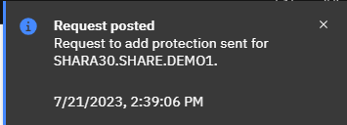

After the Protection job is successful, you should click the refresh icon so that an updated list of data sets is shown.

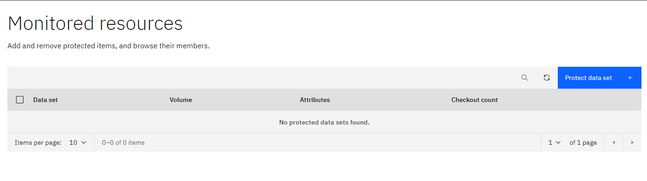

You can also see the history of the commands that you have sent through by clicking the “Session History” tab on the top row.

Note: You can filter the data set protected resource list by using the search icon next to “Protect data set”. This will allow you to search for a single data set name or show the results of multiple data set names under a single high-level qualifier. Since multiple users are completing this lab, you may want to filter on your high-level qualifier so it’s easier to find the data sets.

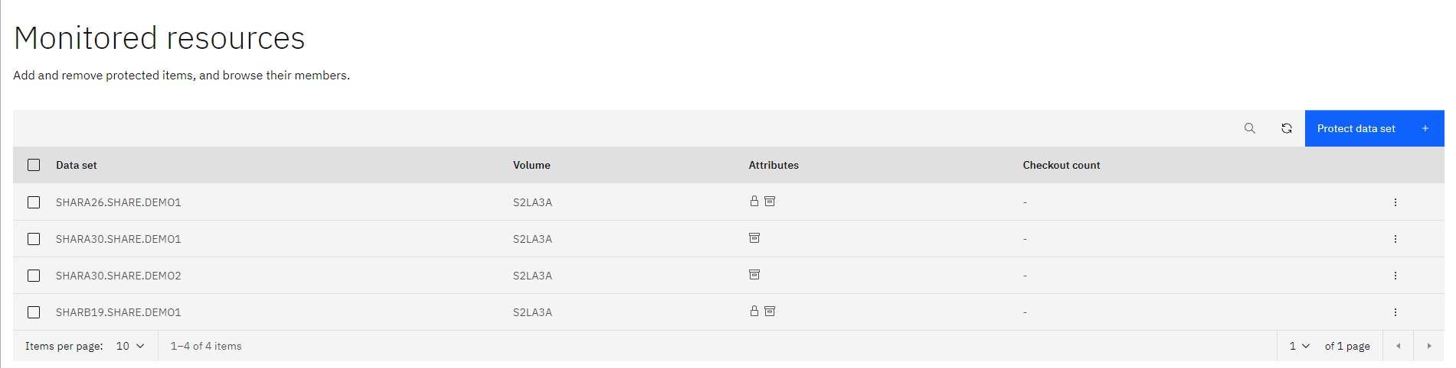

* 1. Locking a data set

Change Tracker has the ability to lock down data sets to avoid users from modifying the data set’s members. If a user wanted to make a change in a member the Change Tracker Administrator would have to check out the member. We will go over this later.

There are two ways to lock a data set with Change Tracker

The first option is to lock the data set when you are protecting it for the first time. In step 2 of this exercise, we went over how to protect a data set. You would select the “Lock” checkbox before protecting that data set and it would be locked from the start.

The second option is to modify the attributes to the data set protection if you want something locked after protecting the data set.

1. At the Monitored Resources panel, find data set SHAR***.SHARE.DEMO1 and click the 3 vertical dots labeled “Options”.

3.a

1. A side panel will be displayed, from here select the “Modify protection” option.

3.b

1. From the Modify Data Set Protection panel, select the Lock checkbox.
2. Click Modify protection to submit the changes.

3.d

3.c

1. After the modification was successfully, select the refresh icon.

3.e

After the Monitored Resources list refeshes, you will see a lock icon under the Attributes column for SHAR***.SHARE.DEMO1. Example:

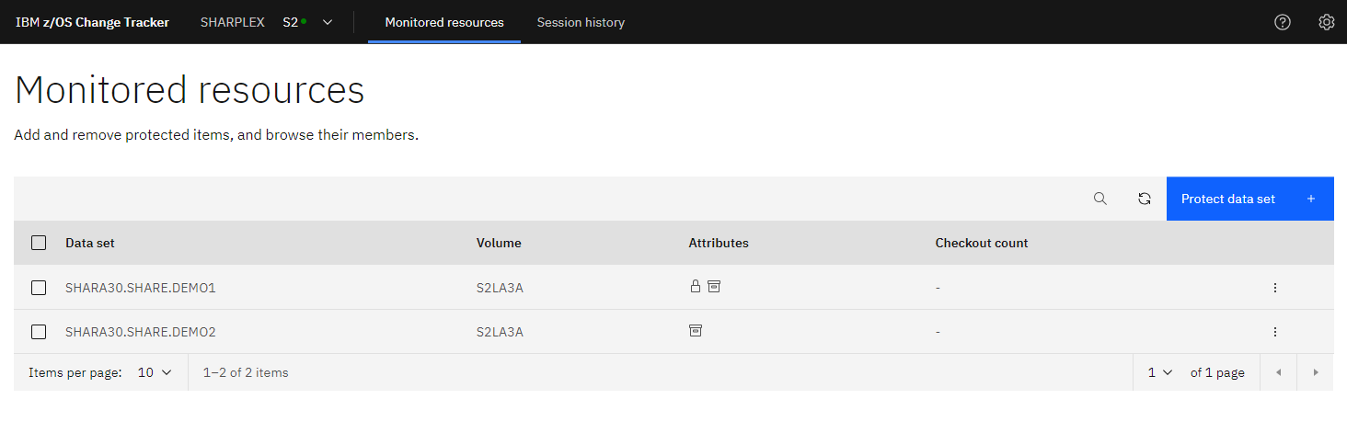

* 1. Check out a member

Once a data set is locked, you need to check out the members inside the data set in order to make changes. For this next step we will walk through the different ways to check out a member. We will also make a change in the member that is checked out so that we can showcase other Change Tracker features in the following steps.

First we need to see the members that are inside our locked data set SHAR***.SHARE.DEMO1. Start at the Monitored Resources Panel.

1. There are three different ways to view the members inside the locked data set.
   1. First option, double-click on the SHAR***.SHARE.DEMO1 name, this will bring you directly to the member panel.
   2. Second option, click the checkbox next to SHAR***.SHARE.DEMO1 and select “View members” on the blue row.
   3. Third option, click the 3 vertical dots labeled “Options”, then select “Browse members”.

4.a.ii

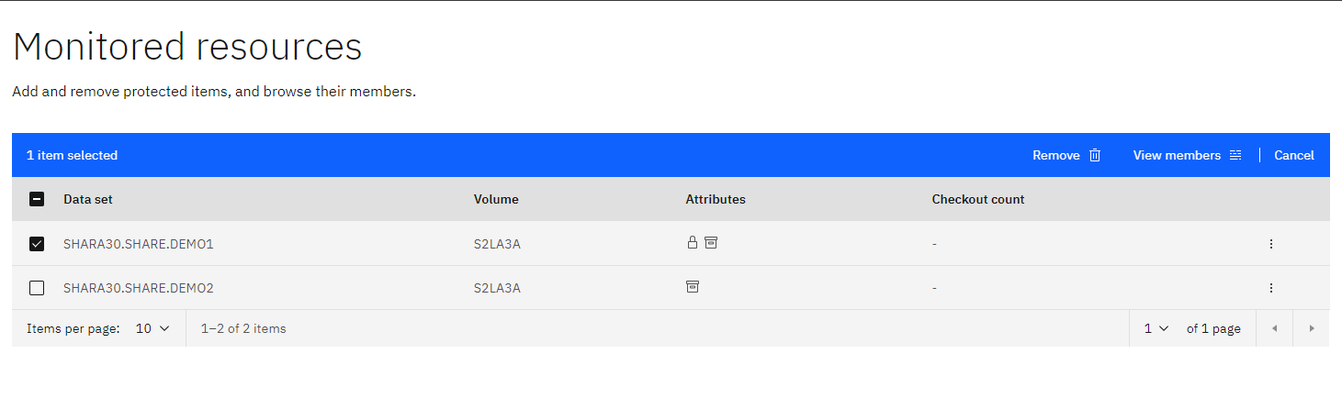

4.a.ii

4.a.i

4.a.iii

4.a.iii

1. Once we can view the members, there are a few different ways to check out a member.
   1. First option, you can select the checkbox next to member CTUPDJOB then select “Check out” via the blue row.
   2. Second option, click the 3 vertical dots labeled “Options”, then select “Check out member”.

4.b.ii

4.b.ii

4.b.i

4.b.i

1. Regardless of the path you chose in the last step, the same “Check out” panel will appear. Under “Check out to” add your userid (SHAR***) and then add a comment “Change Tracker Lab Step 4”.

4.c

1. Click the refresh icon on the top row once you see the successful message.

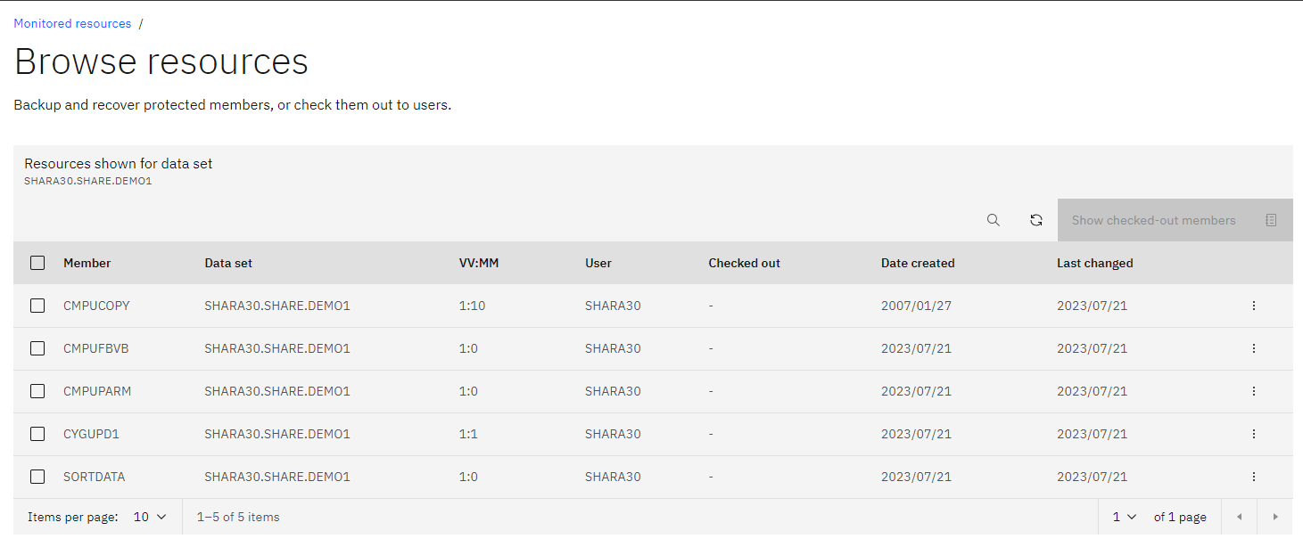

4.d

After you refresh you should see the member is checked out and there is a “Y” under checked out. You can also see checked out members by clicking “Show checked-out members” near the top right.

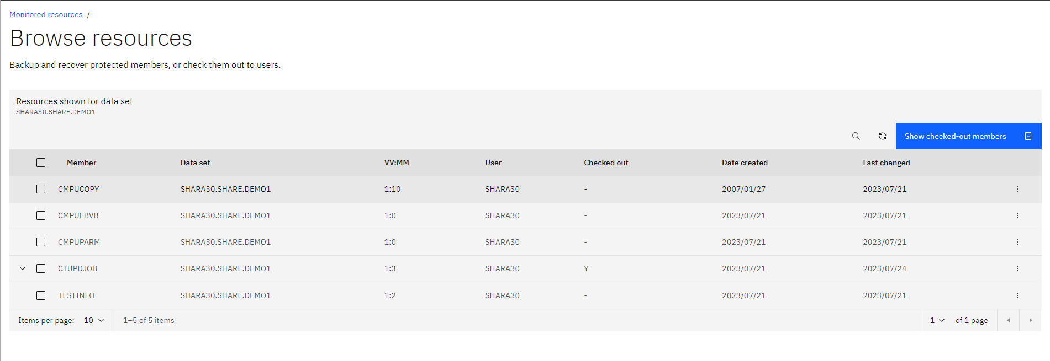

Now that we have the member checked out, we will make a change so that we can use the other features of Change Tracker.

First we are going to change the jobname and data set names in member CTUPDJOB

1. Click the 3 vertical dots labeled “Options”, then select “View Member”.

4.1

4.1

1. After selecting “View Member”, the following will pop up:

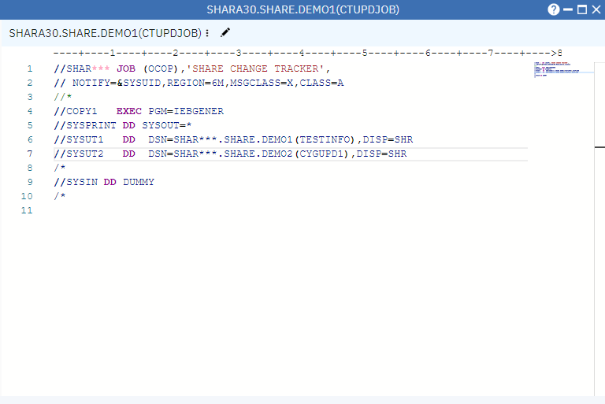

We need to make a change to Jobname and the data set names in SYSUT1 and SYSUT2.

1. Click on the pencil icon next to the data set name to edit.

4.3



1. Make the following changes
   1. Change SHAR*** to your userid that was provided.
   2. Change SHAR*** to your userid that was provided to both SYSUT1 and SYSUT2.



4.4.b

4.4.a

1. The changes should look like the example below except SHARA30 will be the userid provided. Click “Save” in the lower right corner to complete the changes.

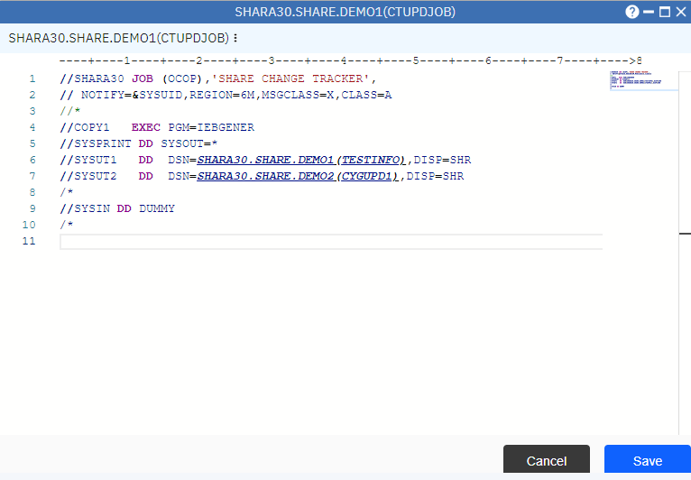

4.5

1. After saving the changes, continue to view the information in the member. Click the 3 vertical dots next to the pencil.

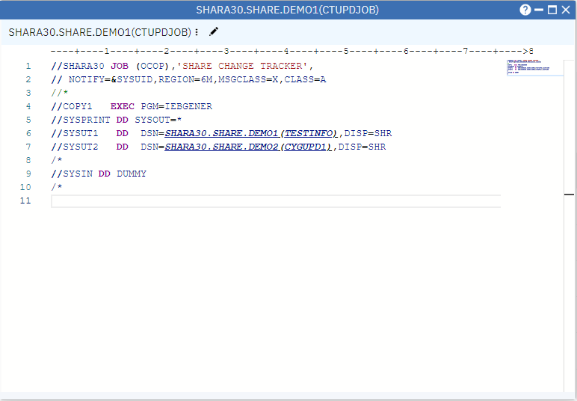

4.6

1. A drop-down menu will appear. Select “Submit as JCL”.

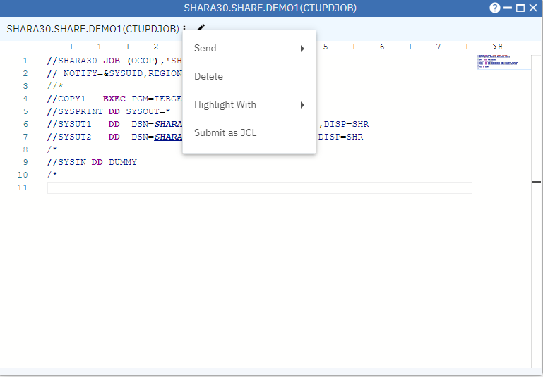

4.7

1. After you submit, the following will pop up. If the CC 0000 does not show up immediately next to the Max – CC, then select the 3 horizontal dots next to the job number. Then select refresh.

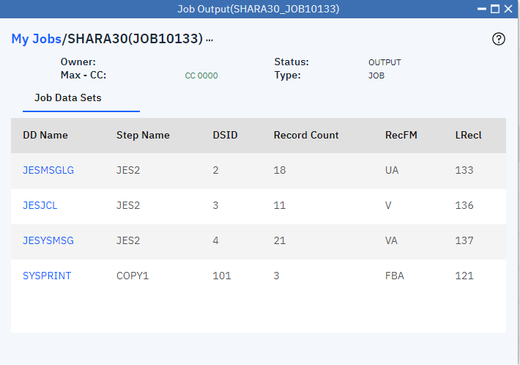

4.8

Now that we submitted a job to change the contents of the member CYGUPD1 in SHAR***.SHARE.DEMO2, let’s view the changes. Go back into Change Tracker and view the members of SHAR***.SHARE.DEMO2. To get back to the Monitored Resource list, click “Monitored Resources” in the upper left corner. Then Repeat step 4.a to get to the member list.

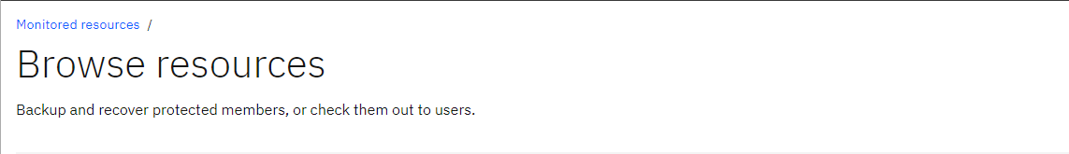

Once you see the members from SHAR***.SHARE.DEMO2, repeat step 4.1 to view the contents. The contents of the member should look like this:

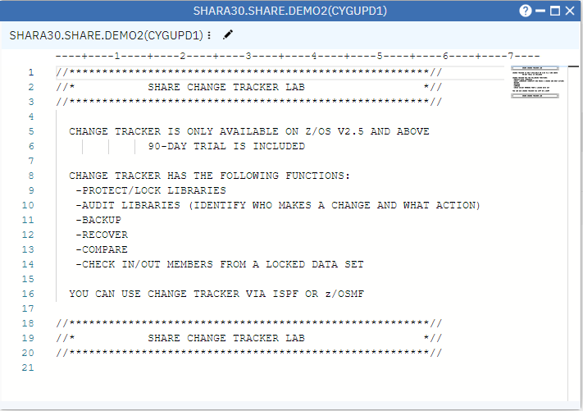

* 1. Audit function

One important feature of Change Tracker is the Audit Function. This allows you to track the changes that occurred to any member or data set. We made some changes to a member during the last step, let’s view the change in the audit log. We are continuing to use the SHAR***.SHARE.DEMO2 data set.

1. On the Browse Resources panel, you should see a list of your members. Find member CYGUPD1 and click the 3 vertical dots labeled “Options”.
2. Select “View audit log” from the drop-down list.

5.b

5.a

After selecting “View Audit log” the panel below will appear. From here you can see the changes that were made by each user. It also has a timestamp and shows what program was called when the changes took place. If the member’s name was changed you will see that under “Old name”.

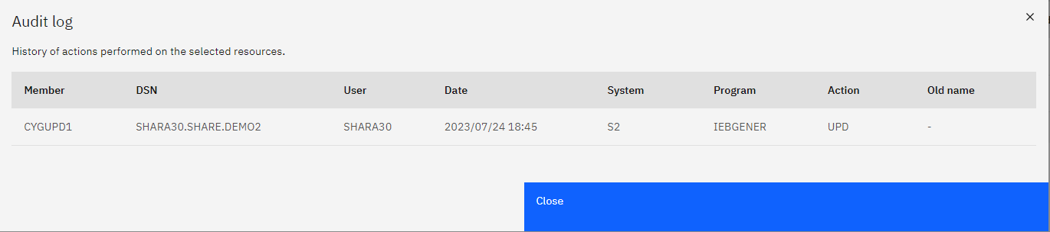

* 1. Compare changes via backups

Change Tracker has a compare function built-in that allows you to compare the changes made between the different backups of a data set. At any given point you can view the changes from the current state of the member to the initial backup of the member or even your original member. This feature is great for understanding the changes that took place within a specific member.

For this exercise, make sure that you are in the Browse Resources panel. This is also the place you view members that are inside a data set. We want to view the members inside SHAR***.SHARE.DEMO2.

1. For member CYGUPD1, click the 3 vertical dots labeled “Options”.
2. Select “Recover backup” from the drop-down list.

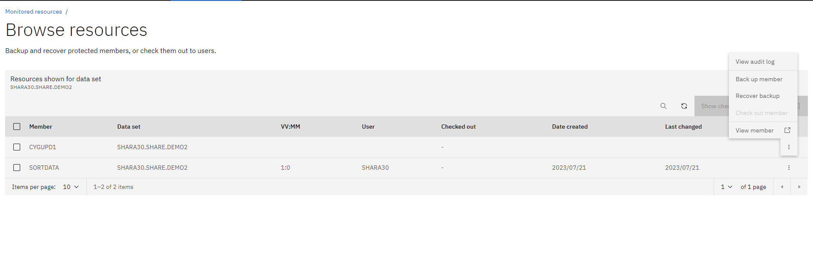

6.a

6.b

1. At the Recover panel you will see a few different things. This shows a list of backups that you have for the member. You can see the intial backup that was taken when we first protected the data set. Under the “Actions” column, find the initial member (Comment should say SYS: -Initial Version) and select the “Compare” Icon.

6.c

After selecting the compare icon, a new window will pop up. This will show the current member on the left and the initial member on the right. You can see any changes made will be highlighted in red.

INITIAL BACKUP

CURRENT

***Please exit the compare window but DO NOT close out of the Recover panel***

* 1. Recover

Recover is a function within Change Tracker that allows you to recover one of your backups. If a change made to a member is causing issues within your environment, this function is great to go back to a version that was working before. There are two options for Recover. One option is to recover into another data set and the other is to Recover in place. Recover in place will overwrite the member that is present in the data set that is protected. For this exercise we will utilize Recover in place.

Make sure that you are still at the Recover Panel. If not, go back to step 6: Compare, to get to the Recover panel.

1. At the Recover panel, find the Initial Version backup and click the “Recover backup” icon.

7.a

1. Select “Recover in place”.
2. Click “Recover backup”.

7.c

7.b

We are going to verify the Recovery was successful.

1. Click the “Data set members” link in the top left. This will bring you back to the list of members in the data set.

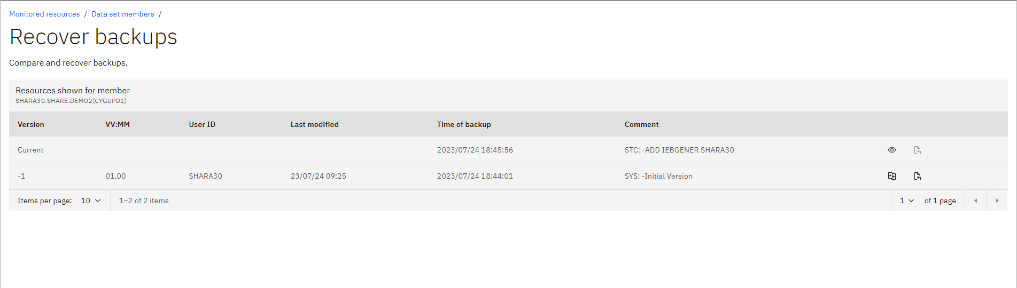

7.d

1. For member CYGUPD1 click the 3 vertical dots labeled “Options”.
2. Select “View member” from the drop-down list.

7.e

7.f

Once you select View, it will pop up a window with the information inside the member.

* 1. Check in a member

For one of the final steps in this lab we will check back in the member that we were using for edits and Recovery. Checking back in a member would happen after you complete all necessary changes or recovery tasks. Checking back in a member is important so the Change Tracker Administrator can check it back out to another user if needed.

Using SHAR***.SHARE.DEMO1, repeat steps 4.a.i – 4.a.iii to return to the members.

1. There are a few different ways to check in a member.
   1. First option, select the check box next to CTUPDJOB, the checked-out member. Then select “Check in” on the blue row.
   2. Select the 3 vertical dots labeled “Options” and then select “Check in member” from the drop-down panel.

8.a.ii

8.a.ii

8.a.i

8.a.i

1. From the Check in member panel, you can see that Change Tracker already populates the userid to which the member is checked out to. Add a comment like “Checking in Step 8”.
2. Select “Check in”.

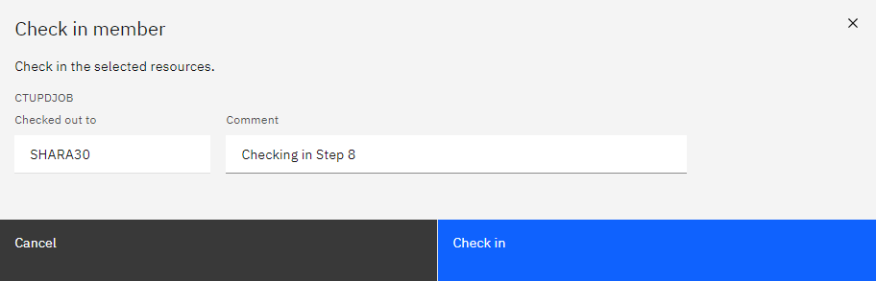

8.c

8.b

1. Select the refresh icon after the job completes.

After the refresh of the list, you should see that the member no longer has a “Y” under the “Checked out” column.

* 1. Remove data sets from the protection list (Cleanup)

For our last step in this lab exercise we are going to unmonitor the data sets that we selected to monitor at the beginning of this lab.

1. At the Monitored Resources panel, select the two data sets SHARA***.SHARE.DEMO1 & DEMO2.
2. On the blue bar select “Remove”.

8.a

8.b

1. Both data sets should show up under the removal screen. Select “Remove” once you confirm both data sets are there.

8.c

1. Click the refresh button to verify both data sets were removed.

If you run into an error make sure you didn’t miss step 7 which was to check back in a member. If you have checked out members it will not allow you to remove the protection.

Alternatively, if you wanted to remove the protection from each data set individually you would:

1. At the Monitored Resource Panel find data set SHAR***.SHARE.DEMO1.
2. Click the 3 vertical dots labeled “Options”.

8.2

8.1

1. From the drop-down menu, select “Remove from list”.

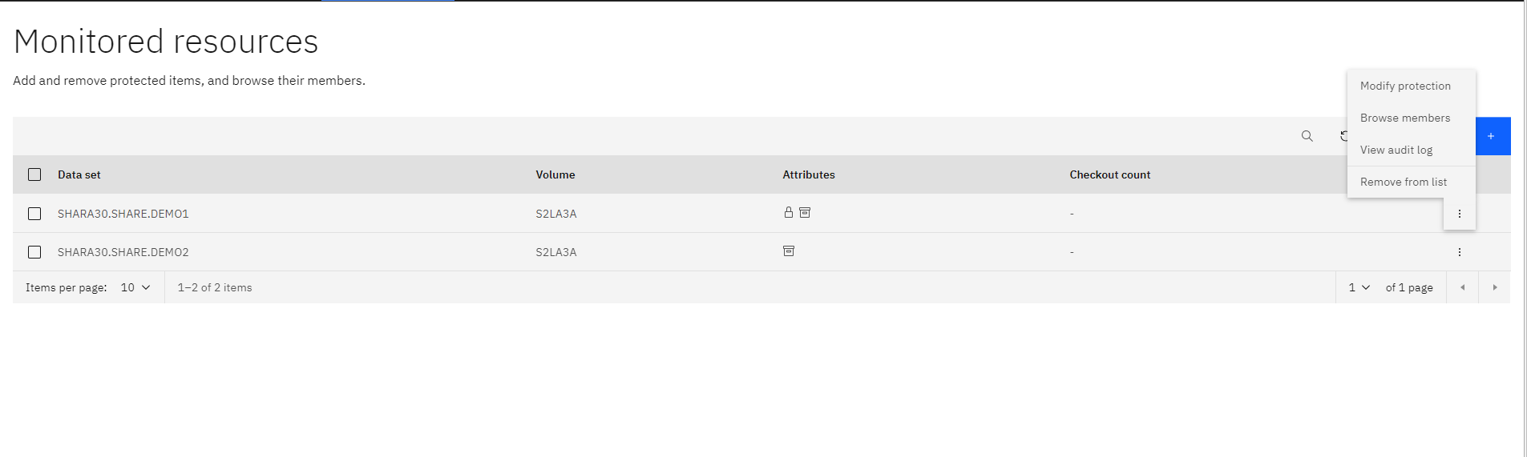

8.3

1. The removal confirmation panel will appear, confirm the data set name and select Remove.

8.4

Repeat Steps 1-4 on DEMO2 if you chose the individual method.